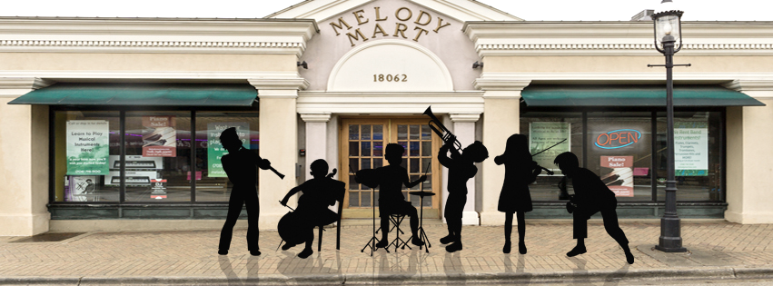
Individual Band/String Lessons

Our Exciting Summer Band Program Begins June 11th!
Let us schedule you for a ½ hour private lesson.
You will work with a degreed, experienced instructor once a week.
You will improve your tone, your fingerings, and your reading of music.

10 Lessons For $199
Register NOW! by visiting our webpage
www.melodymartusa.com

Parents….

Things you should know:
- Program starts Monday, June 11th and Completes Friday, August 24th.
(week of July 4th off, July 2nd-6th)
- Lessons are in store at Melody Mart, Homewood on Dixie Hwy.
- Students must bring their Instrument and School Music Book.
(If you do not have a book or an instrument, you can rent or purchase one from Melody Mart)
- Actual lesson times and days will be determined on an individual basis by June 5th and emailed to signups address.
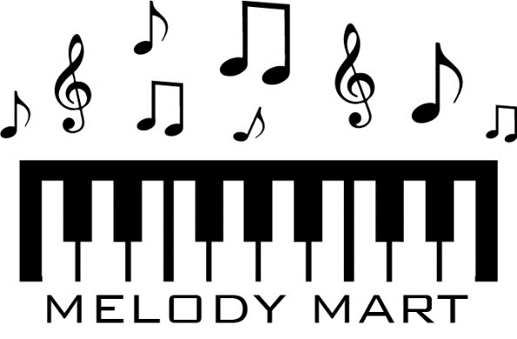
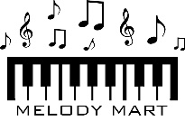
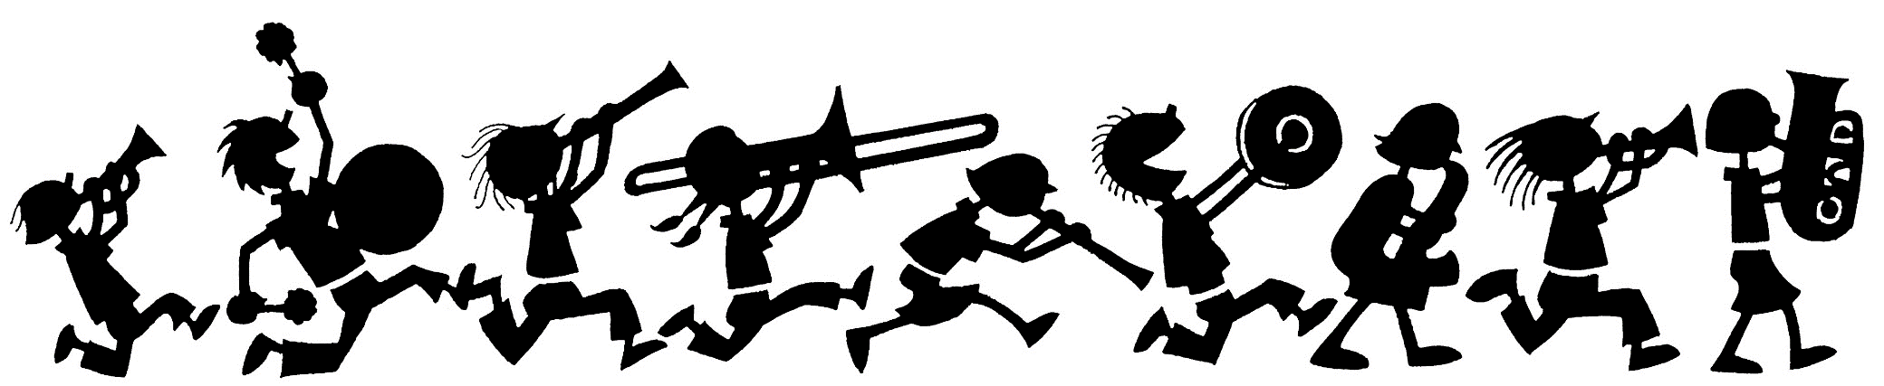
708.798.5500 - 18062 Dixie Highway, Homewood IL

